CLASS MATERIALS SHARING
@CREATIVITY THINK (9483175986/7019689991)

ABSTRACT:
Class Materials Sharing is a web-based platform designed to facilitate the organized sharing of educational content among students, teachers, and study groups. The system allows users to upload, categorize, tag, and share study materials, while providing dashboards for tracking activity and engagement. Administrators can moderate content, manage groups, collect feedback, and generate analytics reports. Built with Django and Django Rest Framework on the backend and React with Dropzone and Redux on the frontend, the platform ensures secure, efficient, and collaborative sharing of academic resources across institutions and study communities..

INTRODUCTION OF THE PROJECT:
Managing and sharing educational materials in schools, colleges, or study groups often relies on scattered platforms or manual processes, causing inefficiencies and disorganization. Class Materials Sharing addresses these challenges by providing a centralized system to upload, organize, and share study documents. Users can tag content, join groups, and track interactions, while administrators ensure appropriate moderation, manage groups, and monitor usage through dashboards. The platform enhances collaboration, improves accessibility, and ensures structured content distribution for academic environments..

PROJECT OBJECTIVES:

• Provide a secure platform for uploading and sharing class materials
• Allow users to categorize, tag, and organize study documents
• Enable group-based sharing for targeted audiences
• Provide dashboards to track content uploads and engagement
• Allow administrators to moderate uploads and manage groups
• Collect feedback and generate analytics for performance insights
• Ensure scalability and secure handling of files
• Support easy collaboration and content discovery for students and teachers

PROBLEM OF THE STATEMENT:
Traditional methods of sharing class materials, such as emails, messaging apps, or manual handouts, are inefficient, disorganized, and difficult to track. Users cannot easily manage or categorize content, while administrators lack tools for moderation and analytics. Class Materials Sharing provides a structured, collaborative environment with secure uploads, group management, dashboard insights, and feedback mechanisms, ensuring that materials are organized, accessible, and monitored..

MOTIVATION OF THE PROJECT:
• To streamline the sharing of study materials across students and groups
• To reduce reliance on unorganized communication channels
• To improve accessibility and content discoverability
• To allow administrators to monitor, moderate, and manage uploads
• To facilitate group-based collaboration and discussion
• To track engagement and feedback through dashboards
• To offer a professional and user-friendly interface for academic use

BLOCK DAIGRAM OF PROJECT:

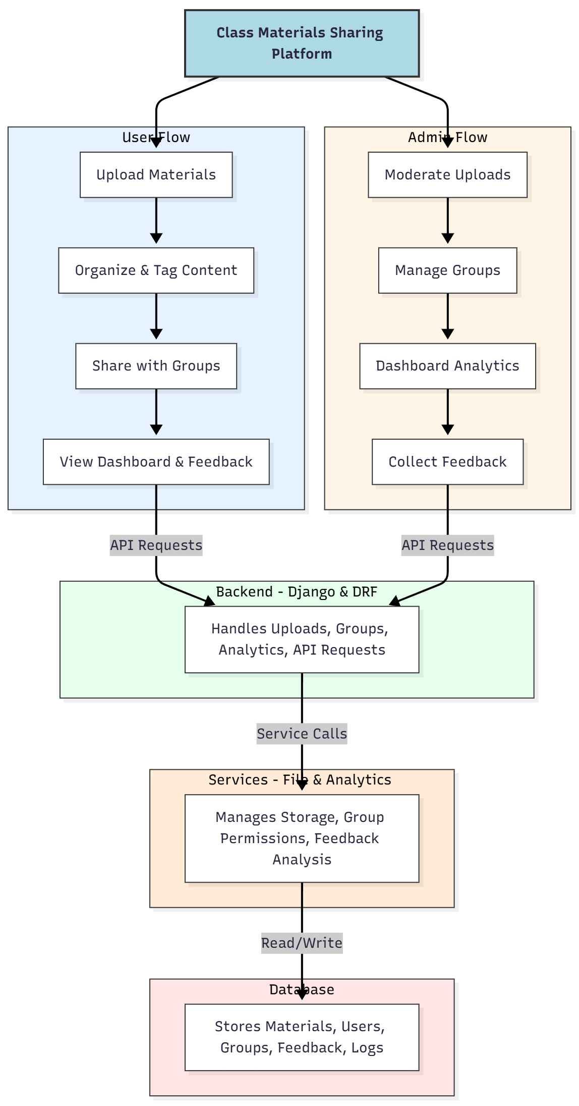

WORKING OF THE PROJECT:
Users begin by uploading study materials through a secure interface. The system allows users to organize and tag content for easy searching and group-based sharing. Shared materials can be accessed by specific groups, and users can view dashboards to track their uploads, interactions, and feedback. Administrators monitor all uploads, manage group memberships, oversee content moderation, and analyze engagement through dashboards. Feedback and analytics services process user interactions, while the database stores all files, group information, logs, and feedback for structured access and reporting..

SOFTWARE REQUIREMENT:
- Backend:
  - Python 3.x
  - Django
  - Django REST Framework
  - SQLite/PostgreSQL
- Frontend:
  - Node.js and npm
  - React.js
  - Axios
- Development Tools:
  - Visual Studio Code
  - Postman (for testing APIs)
  - Git/GitHub (for version control)
- Server/Deployment (Optional):
  - Gunicorn, Nginx, or Heroku/AWS for hosting

ADVANTAGES OF THE PROJECT:

• Organized and structured sharing of class materials
• Group-based content distribution for targeted access
• Dashboard analytics for both users and administrators
• Secure file uploads with permission control
• Feedback collection and moderation support
• Reduces dependency on emails or external messaging platforms
• Enhances collaboration and learning efficiency
• Scalable for schools, colleges, and study groups

APPLICATIONS OF THE PROJECT:
• Schools and colleges
• Study groups and online learning communities
• Academic clubs and societies
• Teacher-student collaborative projects
• Laboratory and departmental material sharing
• Digital libraries and resource management

REFERENCES:

- Django REST Framework Documentation — Django Software Foundation. Django Documentation. Available: https://docs.djangoproject.com/
- Django REST Framework. DRF Documentation. Available: https://www.django-rest-framework.org/
- React. React Official Documentation. Available: https://reactjs.org/docs/getting-started.html
- Redux. Redux Documentation. Available: https://redux.js.org/introduction/getting-started
- PostgreSQL Global Development Group. PostgreSQL Documentation. Available: https://www.postgresql.org/docs/
- MySQL. MySQL Reference Manual. Available: https://dev.mysql.com/doc/
- Git. Git Documentation. Available: https://git-scm.com/doc
- Node.js. Node.js Documentation. Available: https://nodejs.org/en/docs/
- Axios. Axios Documentation. Available: https://axios-http.com/docs/intro
- Socket.io Documentation – https://socket.io/docs/

